Running the SCORE plugin in SonarQube™

# Preliminary Steps

## Install SonarQube™

To add the SCORE plugin to SonarQube™, you must of course have a SonarQube™. If you already have one installed which you plan to use, you may skip this step. Otherwise, you may find directions for installing SonarQube™ at <http://docs.codehaus.org/display/SONAR/Installing+SonarQube>.

Note: It is ***strongly*** recommend to configure SonarQube™ to use a MySQL database rather than the default H2 database, even if you don’t plan to use it for production purposes.

## Get the Jar File

Open a command window at the root directory of the plugin, and execute:

mvn clean install

This will generate the JAR file in the 'target' directory.

# Adding the Plugin to SonarQube™

Copy the jar file from the 'target' directory.

Browse to the location of your installed SonarQube™ directory (we’ll call this SONAR_HOME).

Go to SONAR_HOME/extensions/plugins. Paste the jar file here.

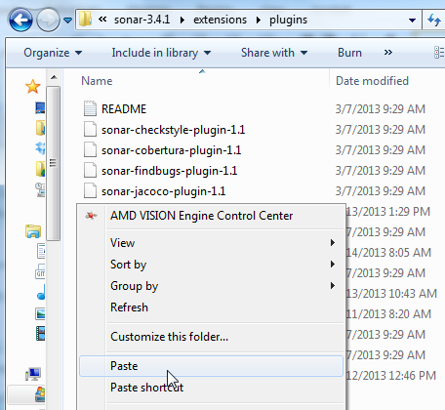

# Moving Additional Files

At this point in the development of the Sonar SCORE plugin, there are a couple of images that are used by the plugin that are not yet installed automatically. Until automatic installation of these images is implemented, they will have to be installed manually. The images are in the SonarScore project, under src/main/resources/images.

The two images and the directories to which they must be added are:

DefaultLogo.png SONAR_HOME\war\sonar-server\images\profiles\projects

TrophyBronze.png SONAR_HOME\war\sonar-server\images\profiles\trophies

If the full path for these directories does not yet exist, then create them.

# Start / Restart Sonar

For Sonar to install the plugin, it must start or be restarted. How you will do this depends on whether or not you have Sonar installed as Windows Service (this session report only covers running Sonar on Windows).

## Batch File (No Windows Service)

If SonarQube™ is running, you must stop it by closing the console that it has open. 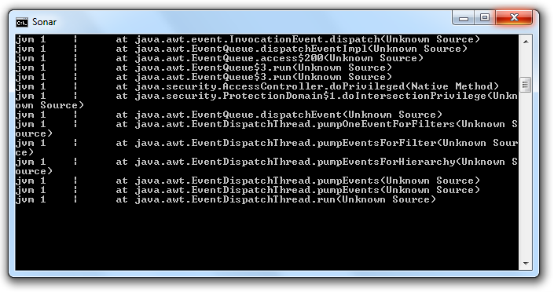

Go to SONAR_HOME\bin\windows-x86-64.

Double click the batch file “StartSonar”.

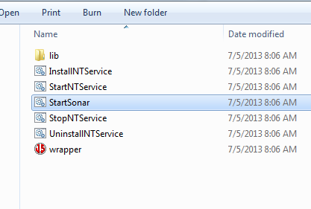

This will open a console (like the one you closed if you had to stop SonarQube™ earlier). It may take a minute, but once the console has printed “9000” (the default port for SonarQube™), Sonar is running. Congratulations, you have successfully added the Score Plugin.

## Windows Service

Go to the Start menu and type in “Services”. Click the Services with the gears icon.

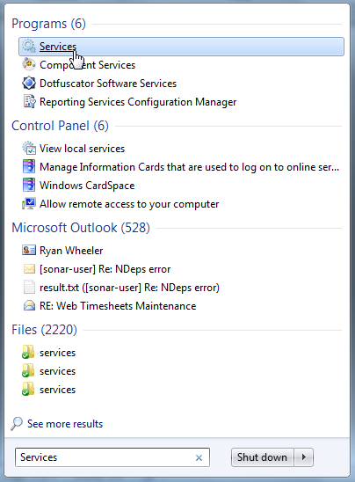

Scroll down to the Service called “Sonar” and start it, or restart it if it is already running.

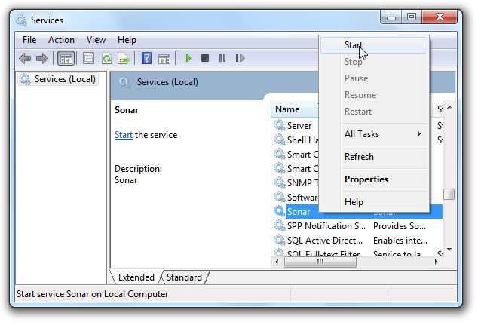

If the service started, Congratulations, you have successfully added the Score Plugin.